Executive Summary
After having utilized multiple digital forensics software, each corroborating the other, there are certain useful, evidence-backed inferences that can be made about the user(s) of the device activity conducted on it. Firstly, there is evidence enough to support fairly average activity being conducted on the device. There is much data that can be found on instant messaging, email, and search engine applications or software, all of which is a standard baseline for most internet users. After digging slightly deeper though, it also becomes apparent that one or more users of the device has a high proficiency with cybersecurity and information technology. Similar to the first conclusion, this one is backed by emails, this time from user(s) of the device stating thot they were apart of a cybersecurity firm. Along with these emails, multiple applications or softwares were found on the drive that would either be too technologically advanced for an average user to understand, or just unnecessary for them to use. On top of both of these is also the usage of basic encryption with a few files, clearly demonstrating s security-conscious user. One final point that can be made about a user(s) of this device was that there is potential evidence that would be helpful in both a criminal and corporate investigation. As shown later in this report, there is evidence of multiple crimes being committed either on or with the assistance of the device. These crimes include semi-minor offenses such as credit or debit fraud, but go as far as child exploitation or grooming at the worst. All of these claims come together to paint the picture of a technologically knowledgeable internet user who has been pursuing a legitimate career and personal life, with a not well hidden, intent to commit crimes.
Methods
Primarily, for this Forensic Report, much of the analysis was done through Autopsy. Autopsy was helpful in organizing every piece of information that existed on the image of that drive in a way that was easy to comprehend and sort through. I also made use of Registry Explorer to extract and analyze some of the registry keys that related to events I had found evidence of occurring in Autopsy but wanted to verify. In the future, I would also like to explore the device’s image more thoroughly. More specifically, it would be interesting to work more on cracking certain password-protected portions of the drive with Kali Linux, as well as carving out certain files to see if I could gain more knowledge about the users of the device.
Findings
- User Account Discovery: What is the name of the main Windows user account?
Based on factors including cookies (see Figure 1), email and instant messaging, file usage and saving, and the number of successful log-ins (see Figure 2), the account with the most activity overall appears to be that of “Frodo Baggins”.
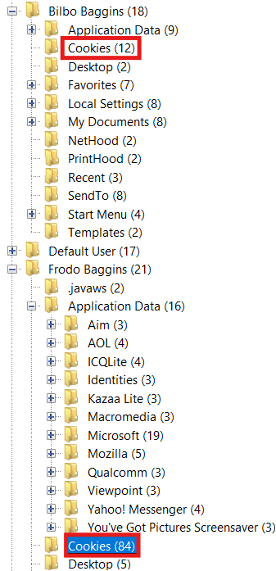
Figure 1: Comparison of the amount of Cookies saved for another user and that saved by Frodo Baggins (as found in Autopsy)
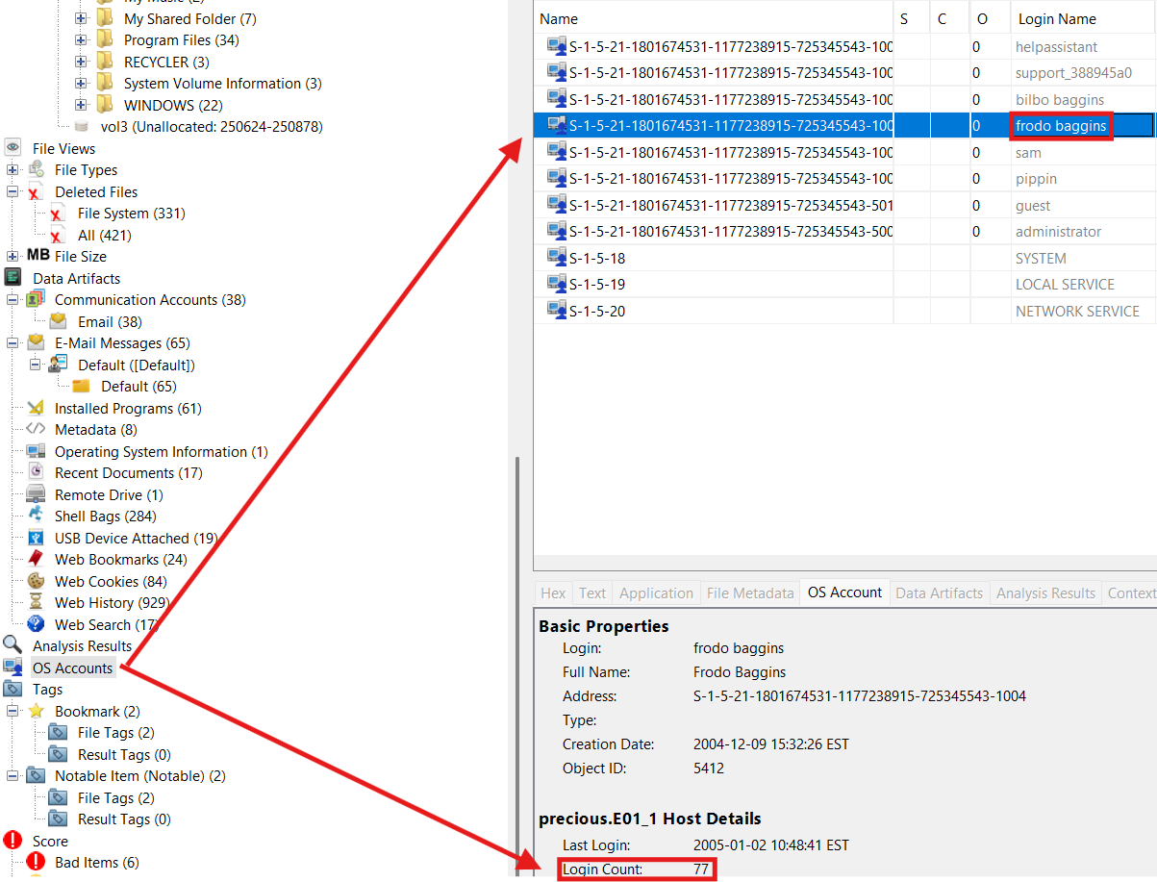
Figure 2: The high number of login attempts for the "frodo baggins" log in credentials (as found in Autopsy)
2) Operating System Version: What operating system is installed?
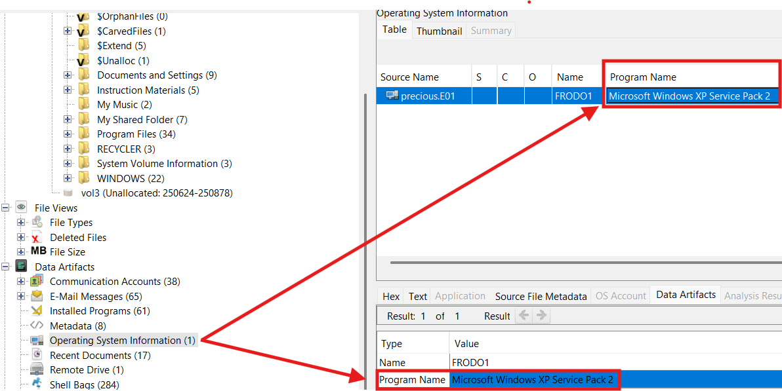
Figure 3: Operating System Information (as found in Autopsy)
Microsoft Windows XP is the installed Operating System of the device, according to the Operating Systems Information under the Data Artifacts tree, as seen in Figure 3.
3) Time Zone: What time zone is the computer set to?
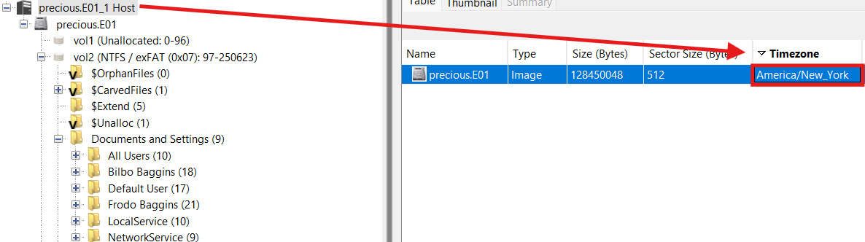
Figure 4: The Time Zone "America/New_York" shown in the information table regarding the precious.E01_1 Host (as found in Autopsy)
The host computer is set to the “America/New_York” Time Zone according to Autopsy, as seen in Figure 4. This is commonly referred to as the Eastern Time Zone in the U.S. The Time Zone the computer uses can also be noticed in many of the files on the computer, which will give the time when a file is Modified, Accessed, or Created in Eastern Standard Time as well.

4) USB Device History: Find one USB storage device that was connected to the
computer and provide the make/model/serial number.
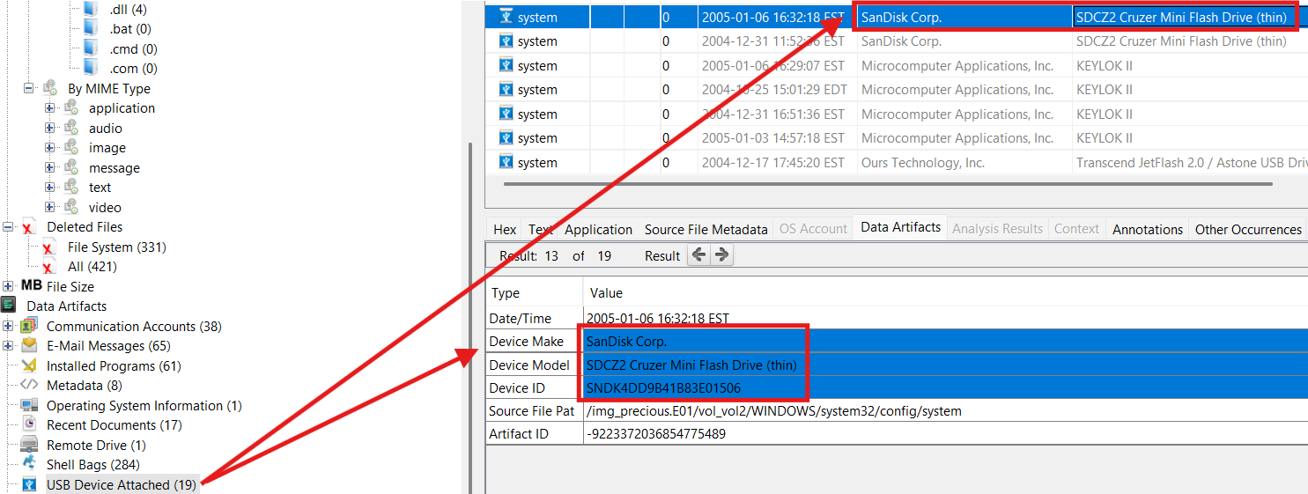
Figure 5: USB Device Connection Data (as found in Autopsy)
As shown in Figure 5 above, a USB storage device that was connected to the device was a SanDisk SDCZ2 Cruzer Mini Flash Drive (thin), with an Identification number of: SNDK4DD9B41B83E01506.
5) Browser History: Identify one website the user visited that could indicate personal
interests.
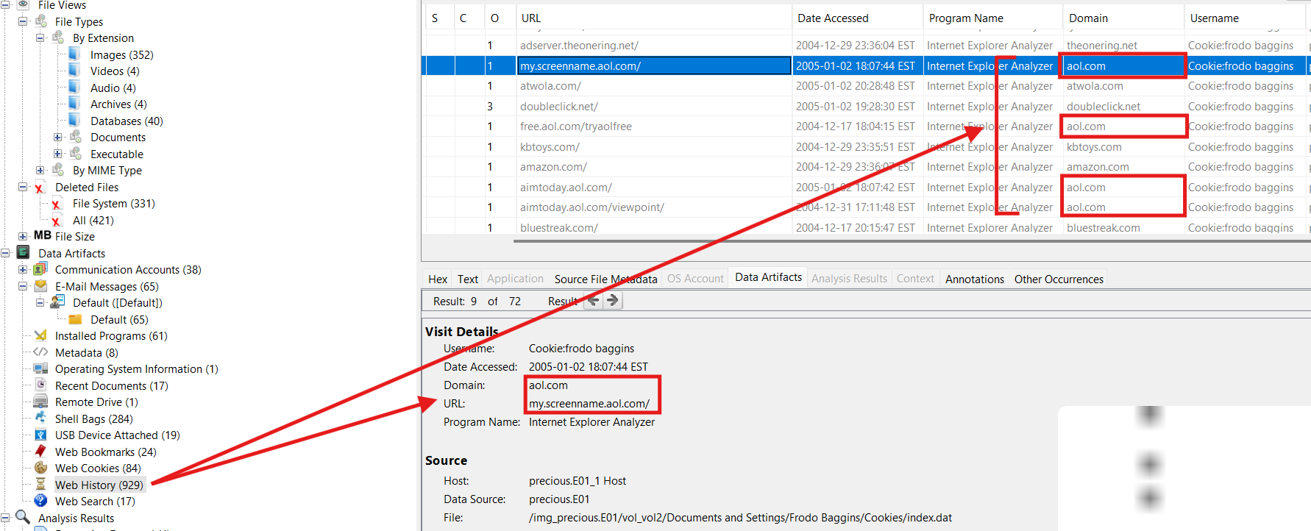
Figure 6: The user's visiting of the website AOL.com is listed frequently under the Web History tree (as found in Autopsy)
One website that continuously appeared in the Web History of the device in Autopsy was the URL of “aol.com”. In fact, as shown in Figure 6, it had been visited 4 times in recent searches. AOL was a popular internet provider and email and instant messaging hosting service from the late 1990s through the early 2000s. It can paint a picture of what the main user may have visited it so often for. The frequency of the visits all contributes to the idea that the user was most likely someone who used AOL for email purposes, to communicate with friends more informally through instant messaging, or was using AOL as his/her internet service provider.
6) Email Attachments: Find at least one email attachment that the user sent.
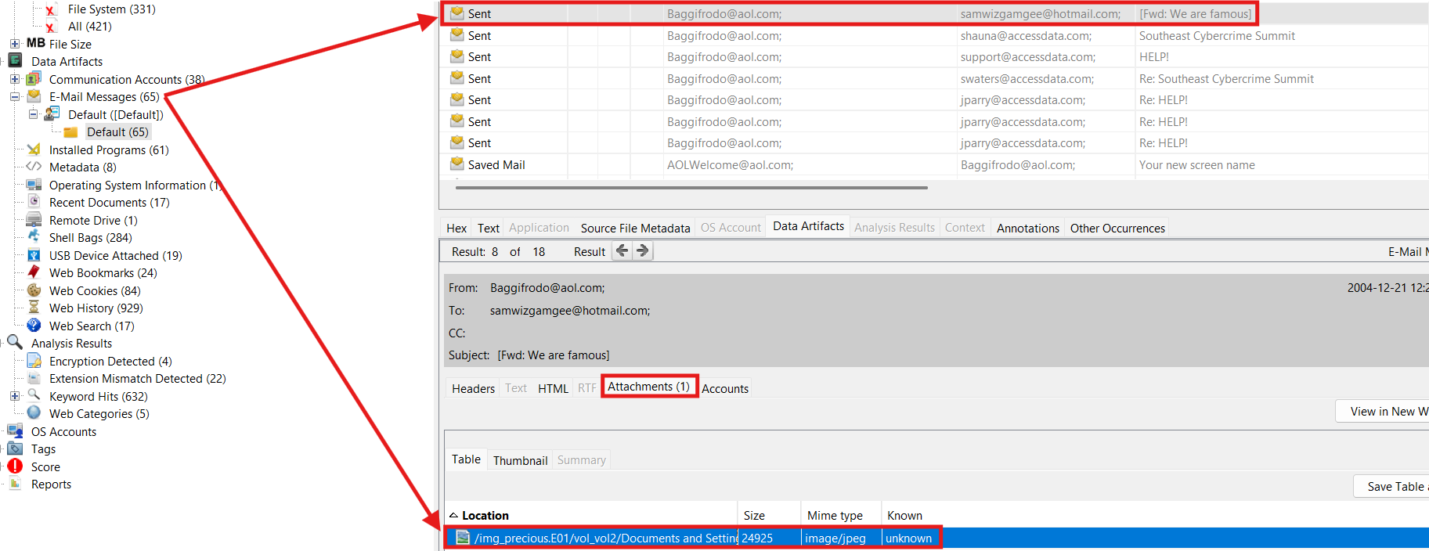
Figure 7: An Email Attachment included in a sent email is listed under the collection of Email Messages (as found in Autopsy)
Among the numerous sent emails listed under the Email Messages on the image of the device, one email, which was a forward of an email with the subject of “We are famous”, had an image file attached to it. The image was a parody of the Lord of the Rings: Fellowship of the Ring cover art, with Homer Simpson in place of where Frodo Baggins would normally be, and the word “Donuts” replacing “Rings” in the title.
7) Recent Documents: Find one document that the user recently opened.
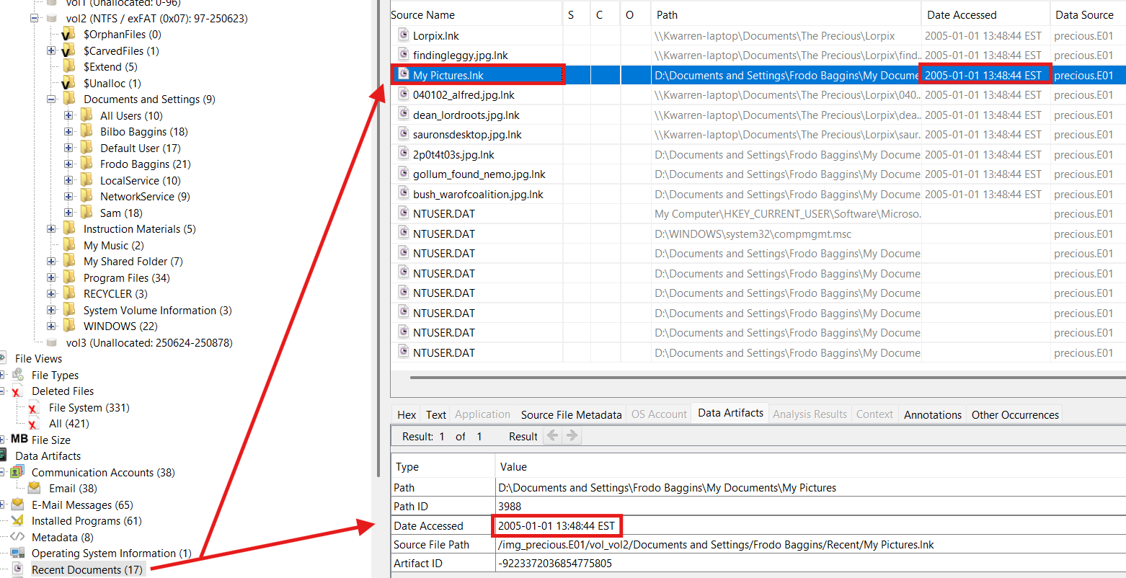
Figure 8: The document "My Pictures" is shown under the "Recent Documents" tree giving an exact date and time accessed (as found in Autopsy)
One document that was recently opened by the user was the “My Pictures” document, as can be seen by the user using the “My Pictures.lnk” shortcut shown in Figure 8, which was accessed on 1/1/25 at 13:48:44 EST.
8) Email Artifacts: Locate at least one email address used on the computer.
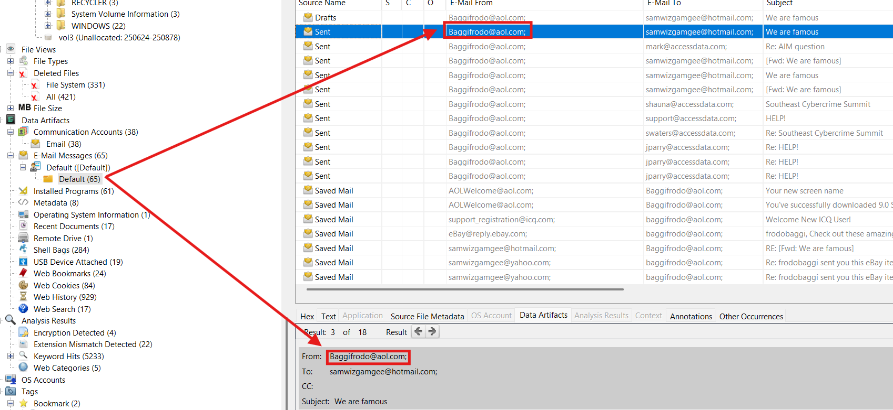
Figure 9: Numerous Emails sent from an account "Baggifrodo@aol.com" show under the default sub-tree of the Email Messages Tree (found in Autopsy)
One of the most used email addresses on the device was “Baggifrodo@aol.com”, where, as in Figure 9, many emails were sent, received, and saved.
9) Pictures: Identify at least three images that could be meaningful.
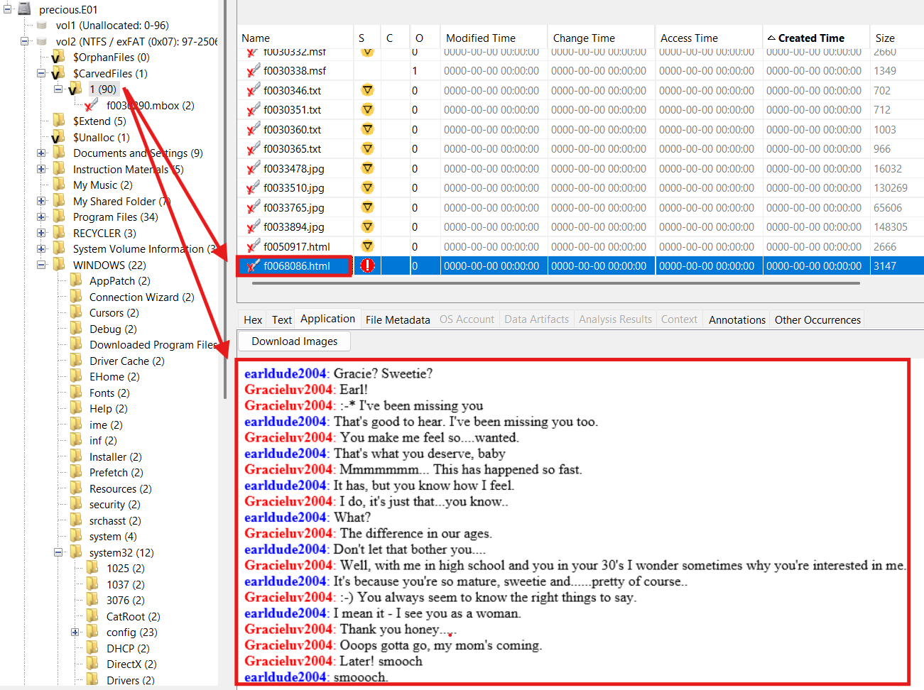
Figure 10: A chat log is stored as an html under the deleted carved files category of the device (as found in Autopsy)
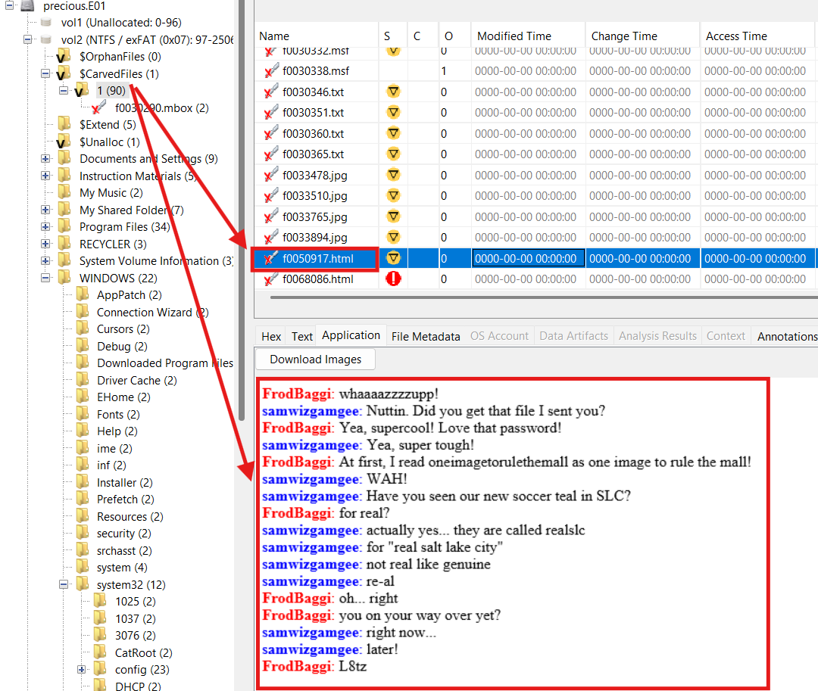
Figure 11: Another html file logging chats between one user and another that uses the device (as found in Autopsy)
10) Software: Identify at least three programs that are installed on the computer.
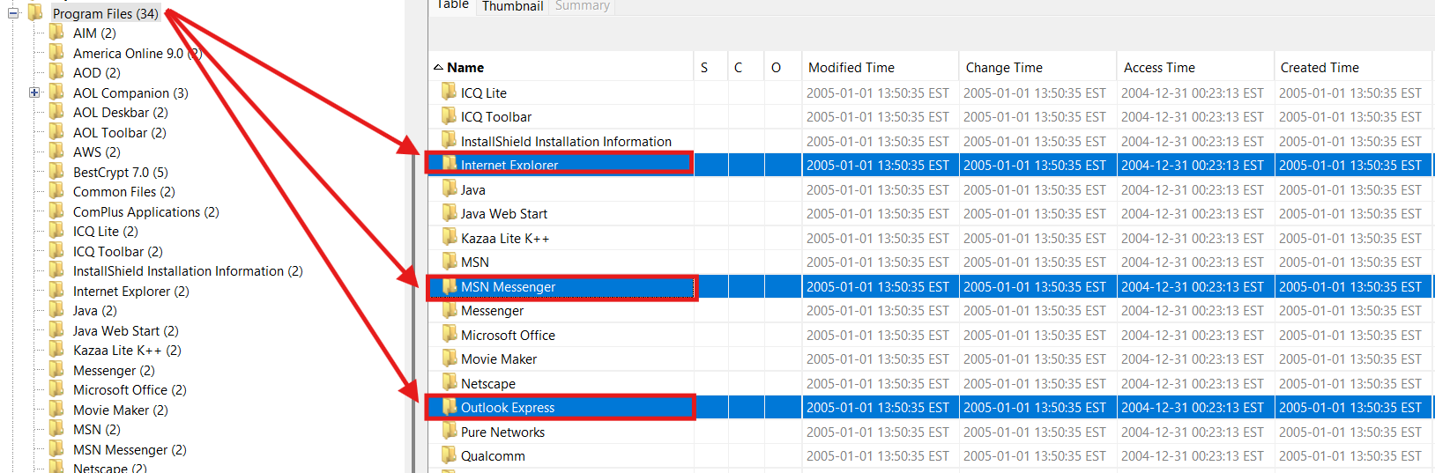
Figure 12: Applications Internet Explorer, MSN Messenger, and Outlook Express shown in "Program Files” (as found in Autopsy)
From analyzing the “Program Files” tree in Autopsy, all the user’s current program files can be seen (as shown in Figure 11), which lists numerous software programs. These programs include a variety of instant messaging apps, such as MSN Messenger, a few Internet browser applications, such as Internet Explorer, and certain email hosting services, such as Outlook Express.
11) System Boot: When is the last recorded system shutdown date and time?
12) Deleted Files: Identify and recover a deleted file.
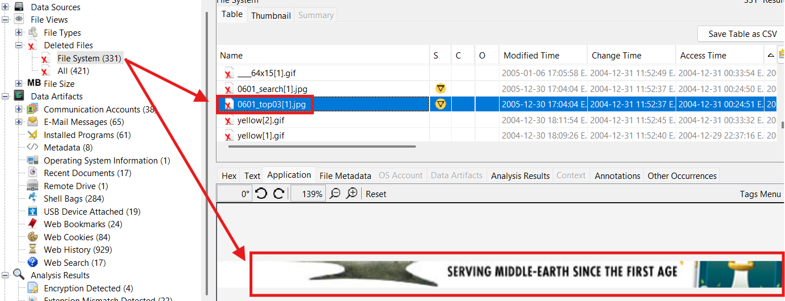
Figure 13: A recently deleted image, still visible in autopsy as it had not been overwritten or made into unallocated space on the drive yet (as found in Autopsy)
While many files on the device had been deleted and had become at least partially corrupted, only leaving metadata that gave little insight into the former contents of the file, there were a few recently deleted files that were still comprehensible. One such file that did not become unallocated space was the one pictured above in Figure 12, where a graphic displaying part of an image concerning “Middle-Earth” is.
13) Did you discover any other interesting evidence on the computer?
Yes, there was quite a bit of additional evidence on the computer that could be of interest in a criminal investigation. Various files are saved pertaining to identity theft, credit card theft, illegal credit card printing tools, and chat logs that are evidence of grooming or exploitation of a minor.

Timeline
Date/Time (EST) | Event Source | Event Description | Relevance
2005-01-03 20:04:52 | Autopsy | Main User Accesses a Document Labeled “Super Secret” based on an NTUSER.DAT Shellbag. | Suspicious title, could contain highly protected information.
2005-01-01 13:49:36 | Autopsy | Main User sends an email inquiring about educating himself and his company on computer forensics. | Demonstrates the user’s level of technical knowledge.

Conclusion
Based on all of the activity that can be proven or inferred from evidence found on the image, there are most definitely some things that can be concluded about the users of the device. For example, from the search history analytics as well as certain chat logs that were saved it can be seen that multiple users, including the main one, use many instant messaging applications including MSN and AOL. From a less innocent perspective, it can also be surmised that a user or users have conducted much research into ways to forge credit and debit cards based on lots of screenshots, web searches, and PDFs saved concerning different necessities related to the crime.
In my experience working through this image, I found that often it was useful to look through certain registry keys on Registry Explorer to verify or corroborate evidence I had found in Autopsy. One such example of this was for the OS information, while Autopsy does a great job at displaying it outright what it had found the OS type to be, it was helpful to be able to check Registry Explorer and find keys that related to the OS, and find that the entries matched one another.
Some of the artifacts, such as Figure 10, could absolutely hold relevance in a legal investigation, and possibly even a corporate investigation as well. Like Figure 10, there are various other pieces of data on the image that could make a case for certain user(s) conducting criminal activity. As previously mentioned, there is also an abundance of evidence that a user of the device was intending on committing some sort of credit or debit card fraud, and seeing as it is illegal, this could be highly relevant in an criminal investigation. It could also hold some relevance in a corporate investigation too though. Some of the stolen credit card credentials were tied to specific financial institutions which may need to conduct a subsequent internal investigation to figure out how or why the numbers were able to be accessed by a malicious actor. This most likely resulted from a poor cybersecurity framework and security measures or was the result of a leak, but either way, both would call for a serious investigation.

